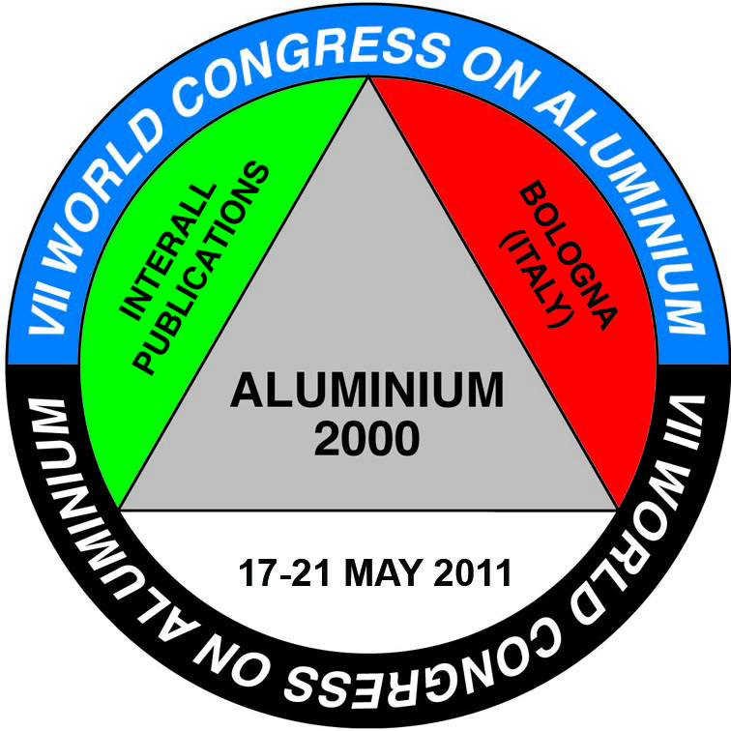
PRESS RELEASE PRESS RELEASE

7th ALUMINIUM TWO THOUSAND CONGRESS
17-21 MAY 2011, BOLOGNA, ITALY
Let’s Build the Future of the Aluminium World Together

Experts of aluminium technologies and aluminium industry managers will gather in the Bologna Spring time at the 7th International Congress “Aluminium Two Thousand” from all over the world and will find “real food for mind”: the new Millennium has brought remarkable advancements in all sectors of aluminium industry but most of them are known only by few people and few companies. The main practical subjects (the themes of the presentations) will be the new technologies for improving automation, productivity, quality, efficiency, ecology. The international appointment in Bologna, the oldest university city in Europe (800 years is the official University age) will be a great and unique opportunity to meet most of the specialists and most of the leading companies (suppliers, customers, end-users). It will also be the proper showcase for all novelties and for getting new ideas and business for the future.
“Let’s Build the Future of the Aluminium World Together” is the motto of the Congress and clearly remarks the importance of common targets and common work.
Automation, Ecology, Efficiency, Productivity, Quality are the 5 key factors which will determine the competitiveness and the future of all the companies in the Aluminium field in the coming years. it is not possible to survive in the industry in the 3rd millennium in a strong competitive environment without improving every day these 5 key factors.

Among the Universities and Institutes promoting the Event there is DIEM-TECH, the Engineering Dept. of Bologna University, already well known for R&D on extrusion technologies.
The Congress will deal with Metallurgy, Extrusion, Surface Finishing, Corrosion, Environmental Technologies and all the most important subjects related to the Aluminium Industry.
Three parallel sessions for three full days will ensure, by mean of 100 papers, that all subjects will be covered in detail and, on top of that, the technical team of the organizing committee will take care of evaluating the presentations and giving priority to the selection of innovative studies and researches, new industrial applications and case histories.
The most important subject is Aluminium Finishing (Anodizing and Coating, 36 papers, including Corrosion Problem Solving).

During the 4th day of the Congress a specific “Extrusion Workshop” is also foreseen, organized and handled by DIEM-TECH, the Engineering Dept. of Bologna University.
Many leading and well known experts from all over the world have already booked their participation as speakers or delegates and many are expected (last congress in Florence there were delegates from 45 countries).

Aluminium Two Thousand Congress offers also the opportunity to promote the brand and encourage the business being Sponsor or Exhibitor. An Exhibit Space during the whole duration of the congress and Sponsorship Opportunities will encourage the business and add high value to the companies participation.
The Congress also includes an attractive Social Program with Gala Dinner, Classical Music Concert, daily tours for accompanying persons and special events.
Who will profit from ALUMINIUM TWO THOUSAND, 7th edition?: Of course extruders, anodizers, coaters, and manufacturers of architectural frames for windows, curtainwalls, fabricators in automotive industry, aluminium distributors, architectural designers, and mechanical and chemical engineers. Financial investors will also be interested.

Booking a ticket for Bologna 2011 will be the ideal choice for better competing, in the new millennium challenges, for the future of aluminium.

Visit the website http://www.aluminium2000.com for the program

Aluminium Two Thousand Congress is organized by Interall, with the support of ALMA Mater Studiorum University of Bologna, AIFM (Italian Association of Metal Finishers), AIM (Italian Association of Metallury), DIEM-Tech (Engineering Dept. Bologna University), Edimet (Multimedia Network), FACE (Federation of Aluminium Consumers in Europe), Metef (International Aluminium Exhibition), Ore and Metals (Publishing House), Metal Dunyasi (Metal world technical magazine) and sponsored by Italtecno (Advanced Technologies of Aluminium), AluMag (The Market Developer), Kauffmann & Sons (Financial Market Consultancy)

